**LAB_2**

**DDL**

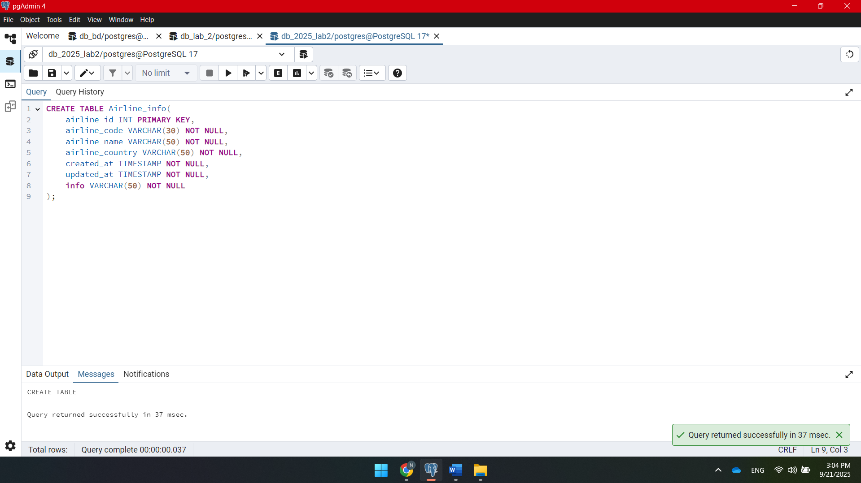

**CREATE TABLE Airline_info(**

**airline_id INT PRIMARY KEY,**

**airline_code VARCHAR(30) NOT NULL,**

**airline_name VARCHAR(50) NOT NULL,**

**airline_country VARCHAR(50) NOT NULL,**

**created_at TIMESTAMP NOT NULL,**

**updated_at TIMESTAMP NOT NULL,**

**info VARCHAR(50) NOT NULL**

**);**

**CREATE TABLE Airport(**

**airport_id INT PRIMARY KEY,**

**airport_name VARCHAR(50) NOT NULL,**

**country VARCHAR(50) NOT NULL,**

**state VARCHAR(50) NOT NULL,**

**city VARCHAR(50) NOT NULL,**

**created_at TIMESTAMP NOT NULL,**

**updated_at TIMESTAMP NOT NULL**

**);**

**CREATE TABLE Baggage_check(**

**baggage_check_id INT PRIMARY KEY,**

**check_result VARCHAR(50) NOT NULL,**

**created_at TIMESTAMP NOT NULL,**

**updated_at TIMESTAMP NOT NULL,**

**booking_id INT NOT NULL,**

**passenger_id INT NOT NULL**

**);**

**CREATE TABLE Baggage(**

**baggage_id INT PRIMARY KEY,**

**weight_in_kg DECIMAL(4,2) NOT NULL,**

**created_at TIMESTAMP NOT NULL,**

**updated_at TIMESTAMP NOT NULL,**

**booking_id INT NOT NULL**

**);**

**CREATE TABLE Boarding_pass(**

**boarding_pass_id INT PRIMARY KEY,**

**booking_id INT NOT NULL,**

**seat VARCHAR(50) NOT NULL,**

**boarding_time TIMESTAMP NOT NULL,**

**created_at TIMESTAMP NOT NULL,**

**updated_at TIMESTAMP NOT NULL**

**);**

C**REATE TABLE Booking_flight(**

**booking_flight_id INT PRIMARY KEY,**

**booking_id INT NOT NULL,**

**flight_id INT NOT NULL,**

**created_at TIMESTAMP NOT NULL,**

**updated_at TIMESTAMP NOT NULL**

**);**

**CREATE TABLE Booking(**

**booking_id INT PRIMARY KEY,**

**flight_id INT NOT NULL,**

**passenger_id INT NOT NULL,**

**booking_platform VARCHAR(50) NOT NULL,**

**created_at TIMESTAMP NOT NULL,**

**updated_at TIMESTAMP NOT NULL,**

**status VARCHAR(50) NOT NULL,**

**price DECIMAL(7,2) NOT NULL**

**);**

**CREATE TABLE Flights(**

**flight_id INT PRIMARY KEY,**

**sch_departure_time TIMESTAMP NOT NULL,**

**sch_arrival_time TIMESTAMP NOT NULL,**

**departing_airport_id INT NOT NULL,**

**arriving_airport_id INT NOT NULL,**

**departing_gate VARCHAR(50) NOT NULL,**

**arriving_gate VARCHAR(50) NOT NULL,**

**airline_id INT NOT NULL,**

**act_departure_time TIMESTAMP NOT NULL,**

**act_arrival_time TIMESTAMP NOT NULL,**

**created_at TIMESTAMP NOT NULL,**

**updated_at TIMESTAMP NOT NULL**

**);**

**CREATE TABLE Passengers(**

**passenger_id INT PRIMARY KEY,**

**first_name VARCHAR(50) NOT NULL,**

**last_name VARCHAR(50) NOT NULL,**

**date_of_birth DATE NOT NULL,**

**gender VARCHAR(50) NOT NULL,**

**country_of_citizenship VARCHAR(50) NOT NULL,**

**country_of_residence VARCHAR(50) NOT NULL,**

**passport_number VARCHAR(20) NOT NULL,**

**created_at TIMESTAMP NOT NULL,**

**updated_at TIMESTAMP NOT NULL**

**);**

**CREATE TABLE Security_check(**

**security_check_id INT PRIMARY KEY,**

**check_result VARCHAR(20) NOT NULL,**

**created_at TIMESTAMP NOT NULL,**

**updated_at TIMESTAMP NOT NULL,**

**passenger_id INT NOT NULL**

**);**

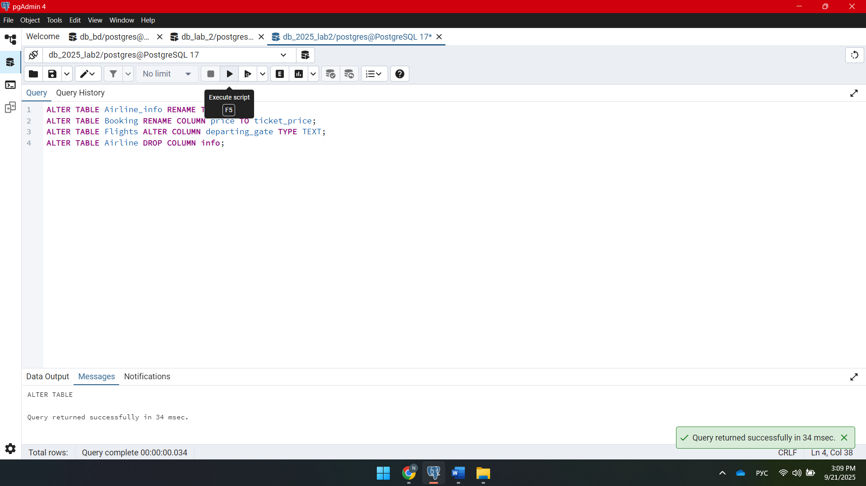

**5** ALTER TABLE Airline_info RENAME TO Airline;

**6** ALTER TABLE Booking RENAME COLUMN price TO ticket_price;

**7** ALTER TABLE Flights ALTER COLUMN departing_gate TYPE TEXT;

**8** ALTER TABLE Airline DROP COLUMN info;

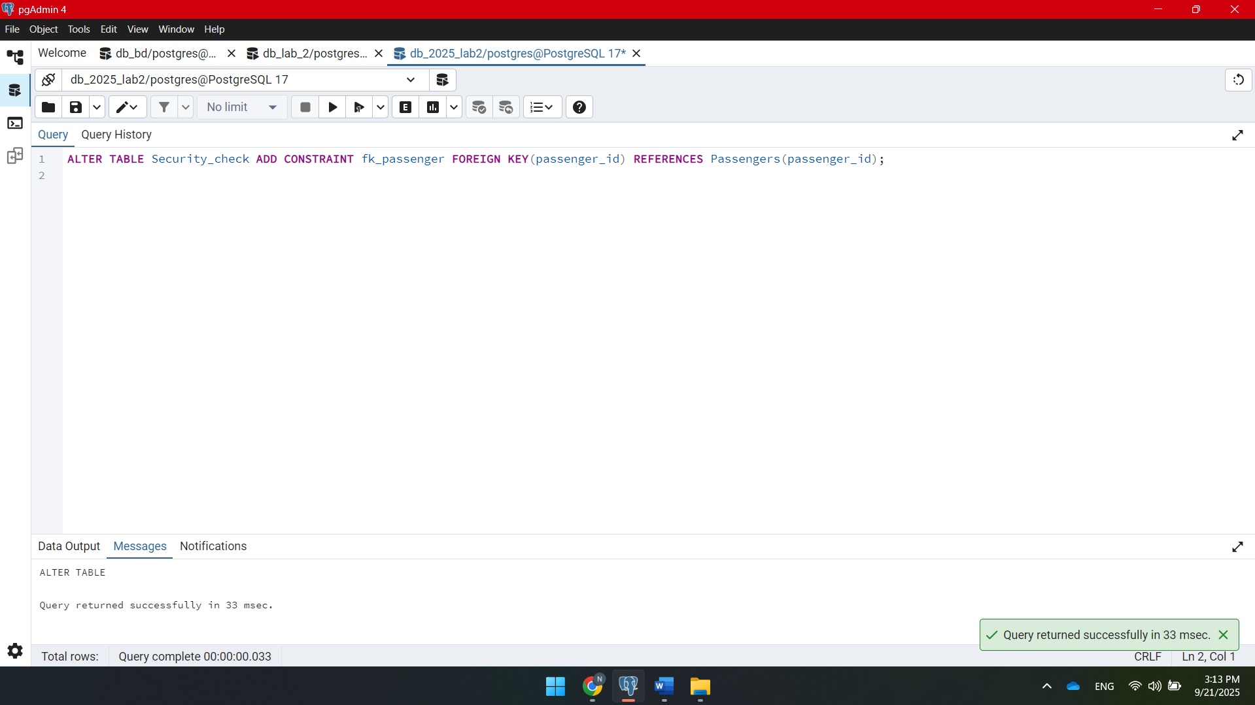

**ALTER TABLE Security_check ADD CONSTRAINT fk_passenger FOREIGN KEY (passenger_id) REFERENCES Passengers(passenger_id);**

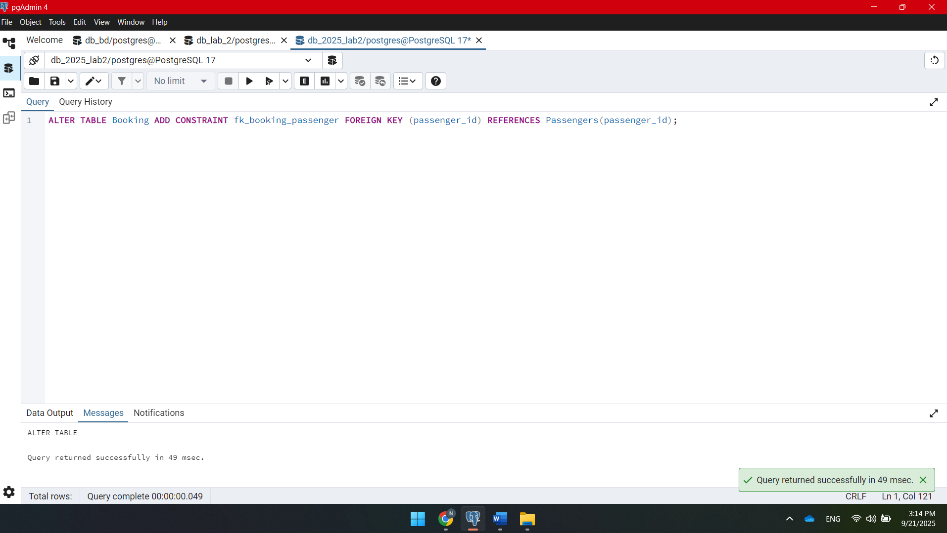

ALTER TABLE Booking ADD CONSTRAINT fk_booking_passenger FOREIGN KEY (passenger_id) REFERENCES Passengers(passenger_id);

ALTER TABLE Baggage_check ADD CONSTRAINT fk_bc_passenger FOREIGN KEY (passenger_id) REFERENCES Passengers(passenger_id);

ALTER TABLE Baggage_check ADD CONSTRAINT fk_bc_booking FOREIGN KEY (booking_id) REFERENCES Booking(booking_id);

ALTER TABLE Baggage ADD CONSTRAINT fk_baggage_booking FOREIGN KEY (booking_id) REFERENCES Booking(booking_id);

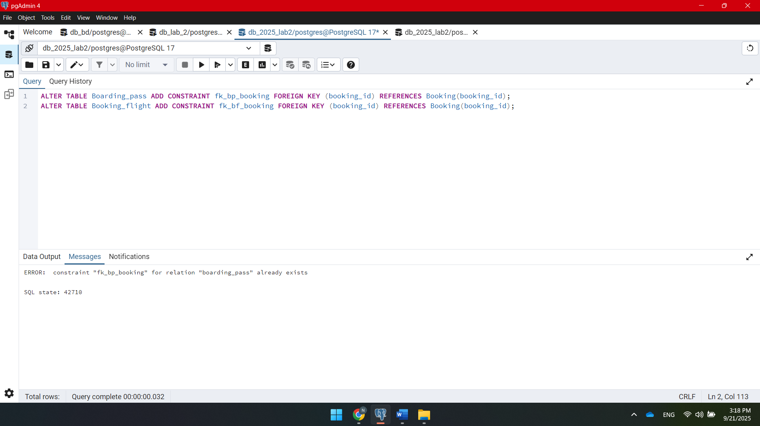

ALTER TABLE Boarding_pass ADD CONSTRAINT fk_bp_booking FOREIGN KEY (booking_id) REFERENCES Booking(booking_id);

ALTER TABLE Booking_flight ADD CONSTRAINT fk_bf_booking FOREIGN KEY (booking_id) REFERENCES Booking(booking_id);

ALTER TABLE Booking_flight ADD CONSTRAINT fk_bf_flight FOREIGN KEY (flight_id) REFERENCES Flights(flight_id);

ALTER TABLE Flights ADD CONSTRAINT fk_flight_depart_airport FOREIGN KEY (departing_airport_id) REFERENCES Airport(airport_id);

ALTER TABLE Flights ADD CONSTRAINT fk_flight_arrival_airport FOREIGN KEY (arriving_airport_id) REFERENCES Airport(airport_id);

ALTER TABLE Flights ADD CONSTRAINT fk_flight_airline FOREIGN KEY (airline_id) REFERENCES Airline(airline_id);

DML

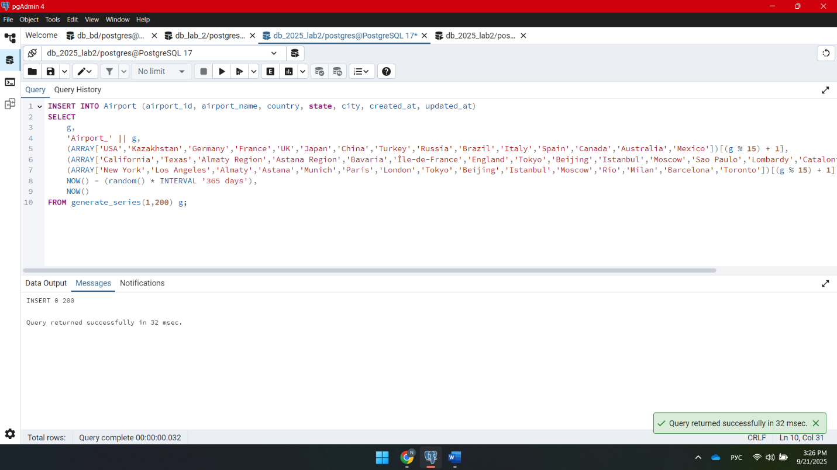

**INSERT INTO Airport (airport_id, airport_name, country, state, city, created_at, updated_at)**

**SELECT**

**g,**

**'Airport_' || g,**

**(ARRAY['USA','Kazakhstan','Germany','France','UK','Japan','China','Turkey','Russia','Brazil','Italy','Spain','Canada','Australia','Mexico'])[(g % 15) + 1],**

**(ARRAY['California','Texas','Almaty Region','Astana Region','Bavaria','Île-de-France','England','Tokyo','Beijing','Istanbul','Moscow','Sao Paulo','Lombardy','Catalonia','Ontario'])[(g % 15) + 1],**

**(ARRAY['New York','Los Angeles','Almaty','Astana','Munich','Paris','London','Tokyo','Beijing','Istanbul','Moscow','Rio','Milan','Barcelona','Toronto'])[(g % 15) + 1],**

**NOW() - (random() * INTERVAL '365 days'),**

**NOW()**

**FROM generate_series(1,200) g;**

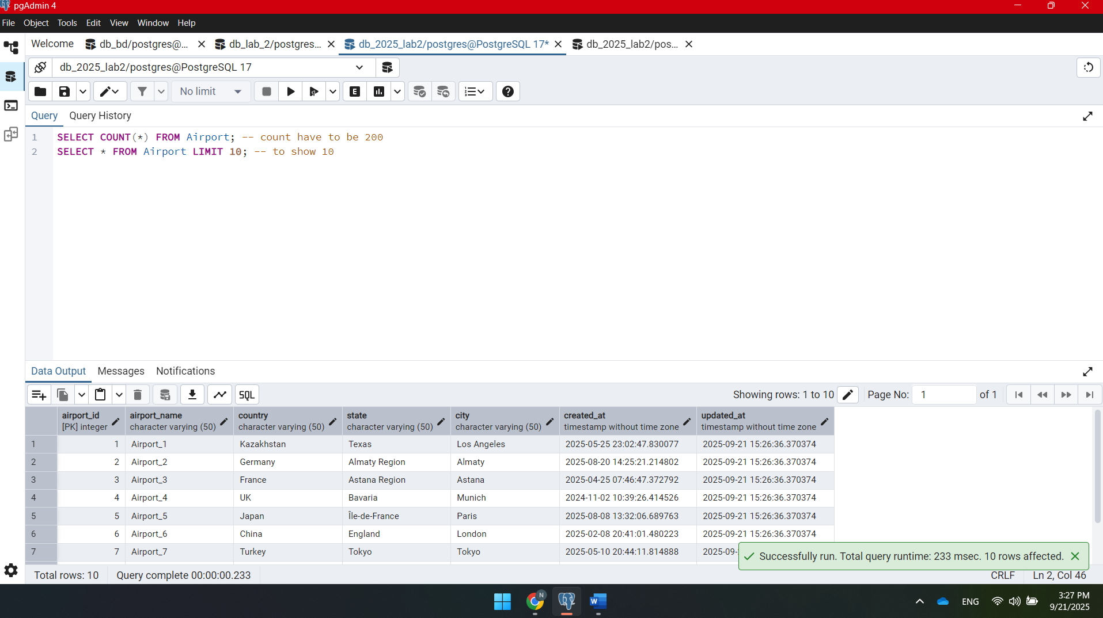

**SELECT COUNT(*) FROM Airport; -- Должно быть 200**

**SELECT * FROM Airport LIMIT 10; -- Посмотреть первые 10 записей**

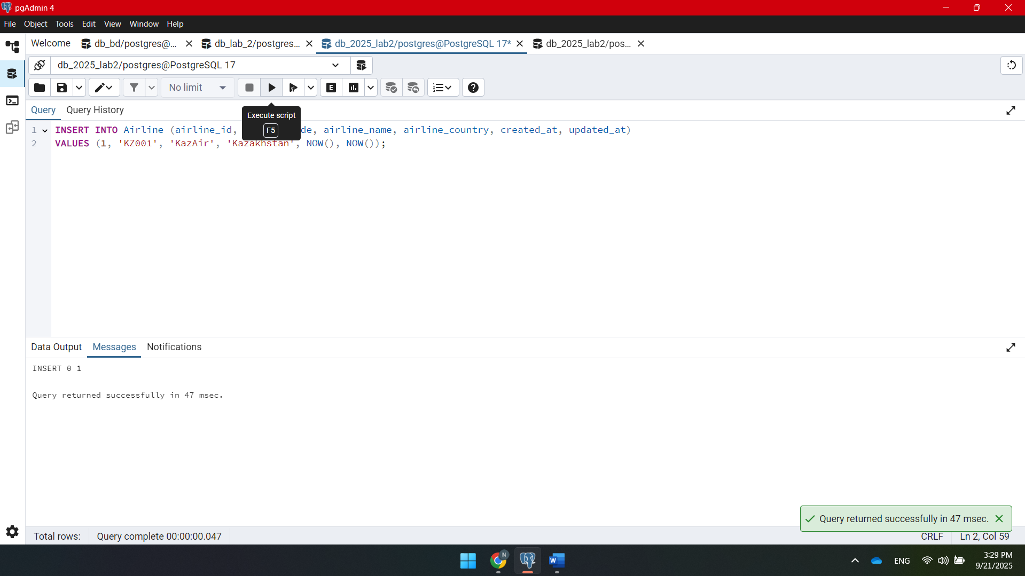

**INSERT INTO Airline (airline_id, airline_code, airline_name, airline_country, created_at, updated_at)**

**VALUES (1, 'KZ001', 'KazAir', 'Kazakhstan', NOW(), NOW());**

**UPDATE Airline SET airline_country = 'Turkey' WHERE airline_name = 'KazAir';**

**INSERT INTO Airline (airline_id, airline_code, airline_name, airline_country, created_at, updated_at)**

**VALUES**

**(2, 'FR001', 'AirEasy', 'France', NOW(), NOW()),**

**(3, 'BR001', 'FlyHigh', 'Brazil', NOW(), NOW()),**

**(4, 'PL001', 'FlyFly', 'Poland', NOW(), NOW());**

**DELETE FROM Flights WHERE EXTRACT(YEAR FROM sch_arrival_time) = 2024;**

**UPDATE Booking**

**SET ticket_price = ticket_price * 1.15;**

**DELETE FROM Booking WHERE ticket_price < 10000;**